8W-CMV : 8Wheeled Caternary Maintenance Vehicle
Purpose: Inspection and Maintenance of Railways’ OHE system (developed for Metro systems of India).
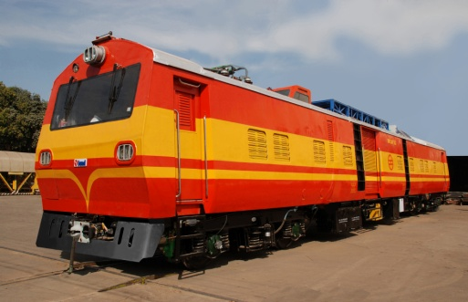
- Dual Power Pack
- Meant for periodic inspection, patrolling and maintenance of overhead equipment on electrified broad gauge rail routes
- Used to attend sites of breakdown of overhead equipment
- Capable of erecting and restoration of damaged small lengths of catenary and contact wires
Functionalities:
- Drivers Cab at both ends
- Staff cabins
- Workshop
- Lifting & Swiveling Platform (Hydraulic)
- Observation Dome
- DG Sets
- Cable Drum Mounting Brackets
- OHE Mast Guides
- Roof mounted pantograph for checking OHE parameters
- Intercom facility between Driver cab and lifting platform
Track Data | Rail Gauge |  |  |  | 1676/1435 mm
Basic Specifications
 |  | Hauling Capacity | 60.4 tonnes(SG)/62.2T(BG), 60 Tonnes-hauling a trailor wagon.
 |  | Maximum Operation Speed 65 kmph
Car Body  Dimensions in mm |  | Length over body  Width over body  Height from rail to  top of roof: |  | 21,366  3,150(BG)/2900(SG)  4,028
Engine |  | NT 855 R 6 of Cummins; 213 kW (285HP) @ 2,100 rpm
Transmission |  | Fully Automatic hydrodynamic transmission Type: SANCRT UP102 (with AVTEC CRT 5633)
Final Drive |  | Axle Mounted Helical Gear Box (double reduction)
Axles |  | Solid forged, 16 Tonne Capacity one powered Axle (powered by one power pack) and one trailing Axle in each bogie.
Brakes |  | - Compressed air brakes with Tread brake units  - Gradual application and gradual release type applied on all wheels  - Pneumatically operated
Bogies |  | Two stage helical suspension with box section fabricated frame
Customers |  | a) Delhi Metro Rail Corporation (DMRC)  b) Mumbai Metro One Pvt Limited (MMOPL)  c) Delhi Airport Metro Express Pvt Limited (DAMEPL)  d) L&T Metro Rail (Hyd.) Limited  e) Ansaldo STS, India  f) Chennai Metro Rail Corporation (CMRL)
Supplied |  | Over 10 Nos.

