Mainline Electrical Multiple Units -MEMUs(for Sub-Urban operations of Indian Railways)
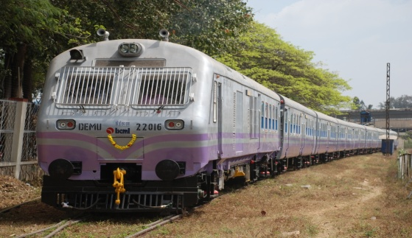
Track Data | Rail Gauge | 1676mm
 | Minimum  Curve Radius | 175 mtrs
 | Maximum Gradient | 1 in 100
Type of Car | DPC, TC | Driving Power Car; Trailer Coach
Basic Specifications
Train Composition | Multiples of 4 Car Unit configurable to 8/12/16/20 | DPC-TC-TC-TC
Axle capacity | DPC | 20.32 tonnes
 | TC | 16.25 tonnes
Tare Weight | DPC | 74.20 tonnes
 | TC | 34.00 tonnes
 | Wheel Diameter | 952 mm (New)  877(DMC)/857(TC) mm (fully worn)
Passenger  Carrying Capacity | Seating Standing  Trailer Coach with Vendors Compartment 97 246  Trailer Coach 96 218  Driving Power Coach 52 34
Speed Control  System  Brake System | Engine RPM Selection to control output of Alternator
Electro Pneumatic Compressed Air Brake with bogie Mounted Brake Cylinder & graduate application & release system.
Tread brake unit with double shoe.
Train Speed | i) Maximum Design Speed 110 kmph
 | ii) Maximum Operation Speed 105 kmph
Car Body  Dimensions in mm | Length over body  Width over body  Height from rail to  top of roof:  Wheel base  Distance between  bogie centers: |  | DPC:21,417 TC: 21,337  3,245  4,025  2,896  14,783
Bogie & Driving  Gear Unit | - Bogie Type  ii) Suspension  · Primary  · Secondary  iii) Driving Gear Unit |  | Light weight high corrosion resistant Bolstered bogie  Bo’-Bo’ arrangement for motor coach  Steel Coil spring  Air Spring  One Stage Helical Gear with bipartite housing
Propulsion System | - Motive Power of 1400 HP from Diesel Engine coupled to 3 Phase 415 Volt alternator.  - Control Equipment Permits Multiple Operation of Units  - 4 Traction Motors of 208 KW each per Driving Power coach
Insulation | Material: Double side aluminium clad Glass Wool
Floor Covering | Material: Al/SS chequered plate
Customer | Indian Railways
Cars Supplied | 160 Nos. (as on 31-Mar-2017)

